Your translation here | Novel Coronavirus –  Useful information
What is thr “Novel Coronavirus”?

A new virus that has not circulated among humans before. This virus is different from previous or current human seasonal viruses, therefore no established treatment exists.

What are the symptoms?

Common signs of infection include respiratory symptoms, fever, cough, shortness of breath and breathing difficulties.
In more severe cases, infection can cause pneumonia, severe acute respiratory syndrome, kidney failure and even death.

How is this virus transmitted?

The new virus is transmitted like normal flu: mostly via droplets when coughing or sneezing.

Transmission can also occur through touching surfaces. The virus is passed from hands to the mouth, nose or eyes.

What is the best means to prevent this virus from spreading?

Increased hygiene measures as outlined below.

Your translation here |  | Novel Coronavirus Best Practices
 |  | 1. Wash you hands and keep them away from your face  Wash your hands with soap several times a day for 20 to 30 seconds, including between your fingers. Use disposal towels. Avoid touching your mouth, eyes and nose.
 | 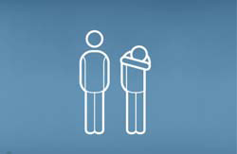 | 2. Be careful how you cough  If you cough, do so away from other people. It’s best to cough into your sleeve, not into your hand. Use disposable Kleenex.
 |  | 3. Watch out for early signs  A sudden high temperature, feeling very ill, coughing and aches and pains all indicate flu.
 |  | 4. Stay at home  Don’t go to work if you are feverish with flu like symptoms. Stay at home and rest until your doctor indicates that you are no longer contagious.
 | 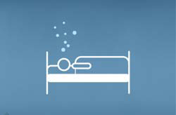 | 5. Get well soon  Get lots of rest and drink lots of fluids. Ask a doctor what else you should do.
 |  | 6. Protect members of your family  If you’re ill, limit all physical contact such as hugging and kissing. Wherever possible, stay in a separate room.  Pay particular attention to hygiene, especially in the kitchen and bathroom.
 | 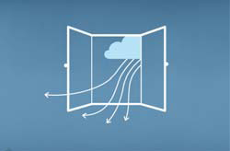 | 7. Air closed rooms regularly  Air rooms regularly (3-4 times a day) for at least 10 minutes. This reduces the number of viruses and improves ventilation.

